**Local Police Report**

**May 2019 ~ Temple Guiting**

Number of incidents reported to police over a twenty four month period:

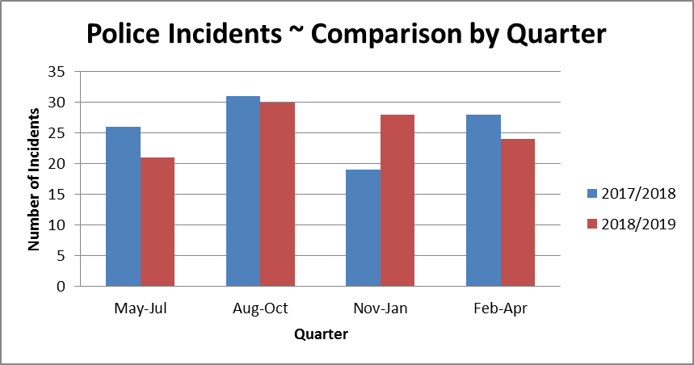

Breakdown of incidents by type reported to police over a twenty four month period:

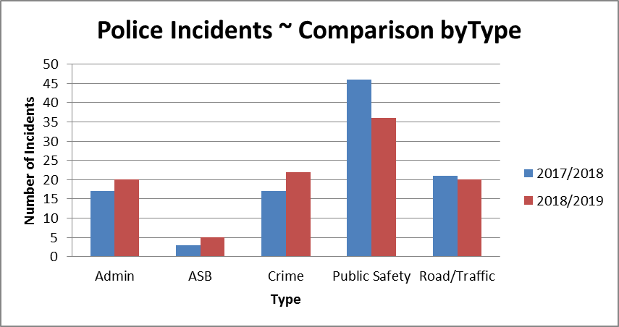

Breakdown of incidents related to crimes dealt with by police over a three month period:

|  |  |  |
| --- | --- | --- |
| **Type of Crime** | **2017/2018** | **2018/2019** |
| Burglary dwelling | 2 | 8 |
| Burglary non dwelling | 3 | 3 |
| Criminal damage | 0 | 3 |
| Crime - other | 2 | 1 |
| Fraud/forgery/deception | 1 | 1 |
| Theft - other | 3 | 1 |
| Theft from motor vehicle | 1 | 3 |
| Theft of motor vehicle | 3 | 2 |
| Violence against the person | 2 | 0 |
| **Total** | **17** | **20** |

**PTO**

|  |  |  |
| --- | --- | --- |
| **Admin**   * Complaint against police * Lost or found Property or animals * Messages inc. press release * Police generated resource activity * Pre-planned event | **Public Safety**   * Alarms ~ Personal, etc. * Animals/Wildlife * Awol/abscond from hmp * Civil dispute-not btw neighbours * Concern for safety * Domestic incident - non crime * Missing Person * Susp. Circs./Insecure veh./prems. | **Road/Traffic**   * Highway disruption * Road related offence * RTC Death / Injury * Rtc_damage only(inc animal rtcs) |

**NB.** Each ‘Incident’ represents a contact report made to the Police via email, 101, 999, <https://www.gloucestershire.police.uk/contact-us/report-a-crime-or-incident/> , F2F with an officer, or at Stow on the Wold Police Station Reception. This being the case, it may be that a single event generates a number of incidents. An example of this could be a single vehicle losing control and damaging a number of properties which could result in a number of ‘Criminal Damage’ incidents.

**For precise details of recorded ‘Crimes’, please visit:** <https://www.police.uk/gloucestershire>

**General:**

The variations over this period in the headline figures for Police Incidents between 2017/2018 and 2018/2019, suggest that Temple Guiting remains amongst the safest Parishes in the County. Indeed, the average daily number of RTC incidents reported for Temple Guiting was 0.02 per day in both 2017/2018 and 2018/2019. The following table compares the daily average number of each type of incident:



This having been said, despite the small numbers, there has been a noticeable rise in the number of burglary related incidents; consequently we would recommend the Parishioners of Temple Guiting take note of the advice set out on the following pages:

<https://www.gloucestershire.police.uk/staying-safe/>

Please rest assured that your Neighbourhood Policing Team in the North Cotswolds continues to take the concerns of the community, together with those of every victim seriously, and endeavours to provide the best service possible; however this must be within the resourcing constraints under which they have to operate.

***We will not be able to attend every meeting we are invited to and on some occasions may have to cancel meetings providing little or no notice due to the nature of Emergency service demands. We will however always provide a Police Report which is designed to provide clear and simple information which can be shared with all those present at the meeting.***

***If questions are raised by those present please note the email addresses of both Beat Managers and PCSOs covering your area. We will be happy to address any concerns you have or that are raised during the meeting.***

***We will endeavour to attend as many meetings as we can but the new format of police Report combined with an up to date list of contact details will be provided for occasions we are not present.***

PC 0436 Jason Page

[Jason.Page@gloucestershire.pnn.police.uk](mailto:Jason.Page@gloucestershire.pnn.police.uk)

PCSO 9251 Charlie Symes

[Charles.Symes@gloucestershire.pnn.police.uk](mailto:Charles.Symes@gloucestershire.pnn.police.uk)

PCSO 9228 John Allen

[John.Allen@gloucestershire.pnn.police.uk](mailto:John.Allen@gloucestershire.pnn.police.uk)