Keeping the village clean - and maybe winning a prize!
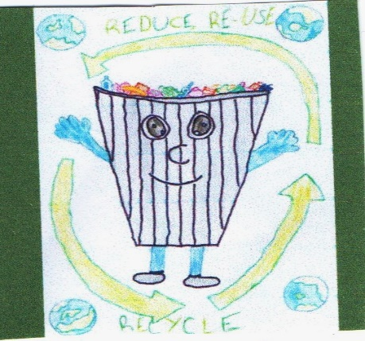 | Once again, CDC is offering a prize for the best Cotswold Clean Up. Schools, community groups and other volunteers are being encouraged to carry out litter picks. CDC will provide equipment and can arrange for filled bags to be collected by Ubico. Just email cdc@cotswold.gov.uk or call 01285 623123 with the location and the name of a community representative.
Grants to local charities
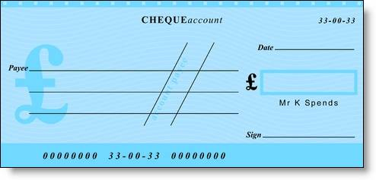 | At the February meeting of Temple Guiting Parish Council, councillors voted to donate to three charities – Cotswold Friends (which provides transport and befriending services) , Community Awareness (which supports vulnerable young people and adults) and the local Citizen’s Advice Bureau.
More quarries in Temple Guiting?
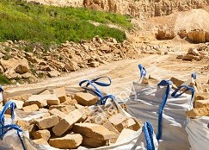 | TGPC has formed a working party to review and respond to the County Minerals Plan 2019-2032 when it becomes available for public comment. This plan will govern when and where further quarries (among other mineral extraction activities) will be allowed. TGPC has already provided extensive input to the draft Plan but in light of the recent scoping request for a new quarry in Temple Guiting, the Council is keen to ensure that local views are fully represented. If you would like to contribute just email templeguitingparishcouncil@yahoo.co.uk. To read the draft plan visit the website.
Help from Highways
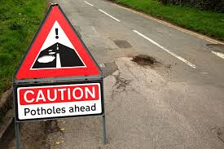 | At a recent meeting with the new Highways Manager for our area and his predecessor, Temple Guiting Parish Council discussed the outstanding requests for help keeping our roads clean and safe. Highways has agreed to tackle a list of works including resurfacing and filling of potholes, speed checks, repairs to signs and maintenance of some verges. The possibility of implementing a 7.5 Tonne weight limit is also being investigated.

More money in the Glos County budget
 | Gloucestershire’s 18/19 budget has been agreed and includes more money for vulnerable children and adults, more for roads and for investment in electric vehicle infrastructure. Included is an extra £10,000 for each local councillor to spend on roads. However, local Council Tax will increase by 2.49%.
Not in our parish but maybe on your way …
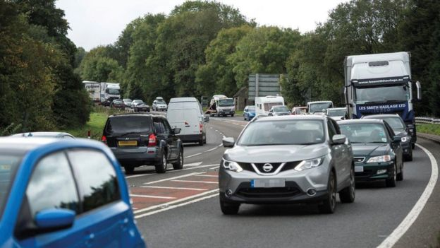 | If you ever drive the A417 towards Gloucester and the M5, you will know that the traffic problems are epic. It is one of the "worst pinch-points" on the national road network. Highways England is looking at two new alternative routes, while also preserving the environment. If you want to see the options under consideration and comment on them visit their website or email A417MissingLink@highwaysengland.co.uk. The nearest place to see plans will be at Cheltenham Library, Clarence Street, GL50 2PZ.

